Subluxations: What are they and what do they do?
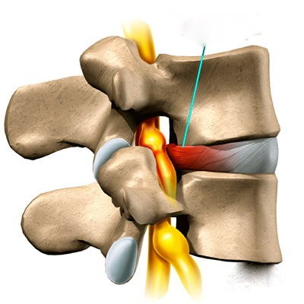
What is a subluxation?
A subluxation, also known as a Vertebral Subluxation, occurs when one or more vertebrae move out of their correct position, and put pressure on or aggravates the spinal nerves. There are the 31 pairs of nerves that emerge from between each of these vertebrae, a.k.a. the bones of your spine. When there is irritation or pressure on the spinal nerves, they fail to function properly. Because of this, signals that travel over the nerves from the body to the brain, and vice versa, are interfered with.
Now, the question is, how does this affect you? The nervous system is what controls and coordinates everything that happens in your body. If the signals traveling over the nerves are interfered with, parts of your body will not function to the best of their innate capabilities because they are not getting the proper message from the nerves. It is a chiropractor’s job to locate these subluxations and interferences to the spinal nerves, and correct or reduce them. How is this done? Through specific, scientific chiropractic adjustments. Chiropractors are the only health care professionals who undergo years of training in order to become experts at correcting these subluxations.

A little more detail…
Subluxations are a combination of changes that occur at the same time, within your spine and throughout your body. Chiropractors often refer to vertebral subluxations as the “Vertebral Subluxation Complex” (VSC).
Various things occur inside your body simultaneously in the VSC. These changes are known as “components,” and these components are all part of the VSC. There are five component categories that chiropractors commonly recognize in the VSC. They are:
- The Osseous (bone) Component, also known as kinesiopathology. This occurs when the vertebrae are either out of alignment, not moving the way they should, or undergoing physical changes (i.e. degeneration).
- The Nerve Component, also known as neuropathology. This is the malfunctioning of the nerve. Even a small amount of pressure exerted on spinal nerves can had a profound impact on their function.
- The Muscle Component, also known as myopathology. Muscles are an integral part of any VSC because they are what hold the vertebrae in place and the spinal nerves are what control the muscles. Muscles are both the effect on the VSC, and are affected by the VSC.
- The Soft Tissue Component, also known as histopathology. This is when the pressure on the nerves causes changes to occur to the surrounding soft tissue of the misaligned vertebrae. The soft tissue, such as ligaments, tendons, blood supply, and other tissues experience changes that can occur at the point of the VSC, or as far as the end point of the affected nerves.
- The Chemical Component, also known as biochemical abnormalities. This is the chemical changes that occur when all of the other components of the VSC are acting on your body. Depending on what your subluxation is affecting in your body, these chemical changes can be slight or massive.
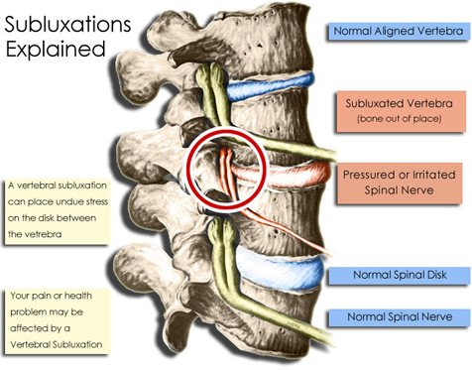
The dangers of subluxations have been known by chiropractors for over 100 years. Today, due to scientific advancements, evidence from research shows these dangers, as well as the health benefits when these subluxations are corrected. It is vital for your nervous system to function to the best of its ability, free of interferences from subluxations, in order for you to be truly healthy. The goal of chiropractors is to enable your body to return itself to the highest level of health. The way to achieve this goal is through correcting vertebral subluxation complex through specific, scientific chiropractic. The only professionals trained in the detection, location, and correction of subluxations are chiropractors.

